Contract Management System
Use Case Document


 | Prepared By / Last Updated By | Reviewed by | Approved By
Name | Saiayyappa O R, Vineka Vellimalai, Vignesh U, Deepika Gnanamoorthy. | Saiayyappa O R, Vineka Vellimalai, Vignesh U, Deepika Gnanamoorthy | Poonkuzhali Anand
Role | Team Member | Team Member | Scrum Master
Signature
Date

Table of Contents
1.0 Introduction 3
1.1 Purpose & Scope of the document 3
1.2 Intended Audience 3
1.3 Use case ‘User Registration’ 3
1.3.1 Use case attributes 3
1.3.2 Use Case Model 4
1.3.3 Business Rules 4
1.3.4 UI Requirements 4
1.3.5 UI Field Validations 5
1.4 Use case ‘User Credential Authentication’ 6
1.4.1 Use case attributes 6
1.4.2 Use Case Model 7
1.4.3 Business Rules 7
1.4.4 UI Requirements 7
2.0 Database Design 8
2.1 Tables Structure 8
3.0 Change Log 10

Introduction

Purpose & Scope of the document
The purpose of this Use case document is to systematically capture requirements for the project and the system to be developed in terms of use cases. Functional use cases are captured in this document. It also serves as the input for the project scoping.

The scope of this document is limited to addressing the use cases from a user, quality, and non-functional perspective.

Intended Audience
Each member of the project team

Use case ‘User Login’

Use case attributes
Use Case Description:

This use case deals with the capture of user details. The ‘user (Admin/Supplier)’ here shall be the operator of the system and will be keying in the contract information into the system.

Scope:

- User(Admin/Supplier) registration

Actors:

- User(Admin/Supplier) – the operator

Trigger:

Click ‘Submit’ button in the ‘User (Admin/Supplier) Registration’ page

Pre-Condition:

User (Admin/Supplier) being able to access the homepage & get redirected to the ‘User (Admin/Supplier) Registration’ page based on Admin/Supplier upon click of ‘Register if new’ link.

Post Condition:

User (Admin/Supplier) is in the enrollment page & submit details

Flow of Events:

User (Admin/Supplier) at homepage → Click ‘Register if new’ link → User (Admin/Supplier) is in the enrollment page → User (Admin/Supplier) details are submitted and added onto the database

Primary Scenario:
A new user (Admin/Supplier) – is able to click ‘Register if new’ link and able to provide his details and get enrolled in the system.

Use Case Model
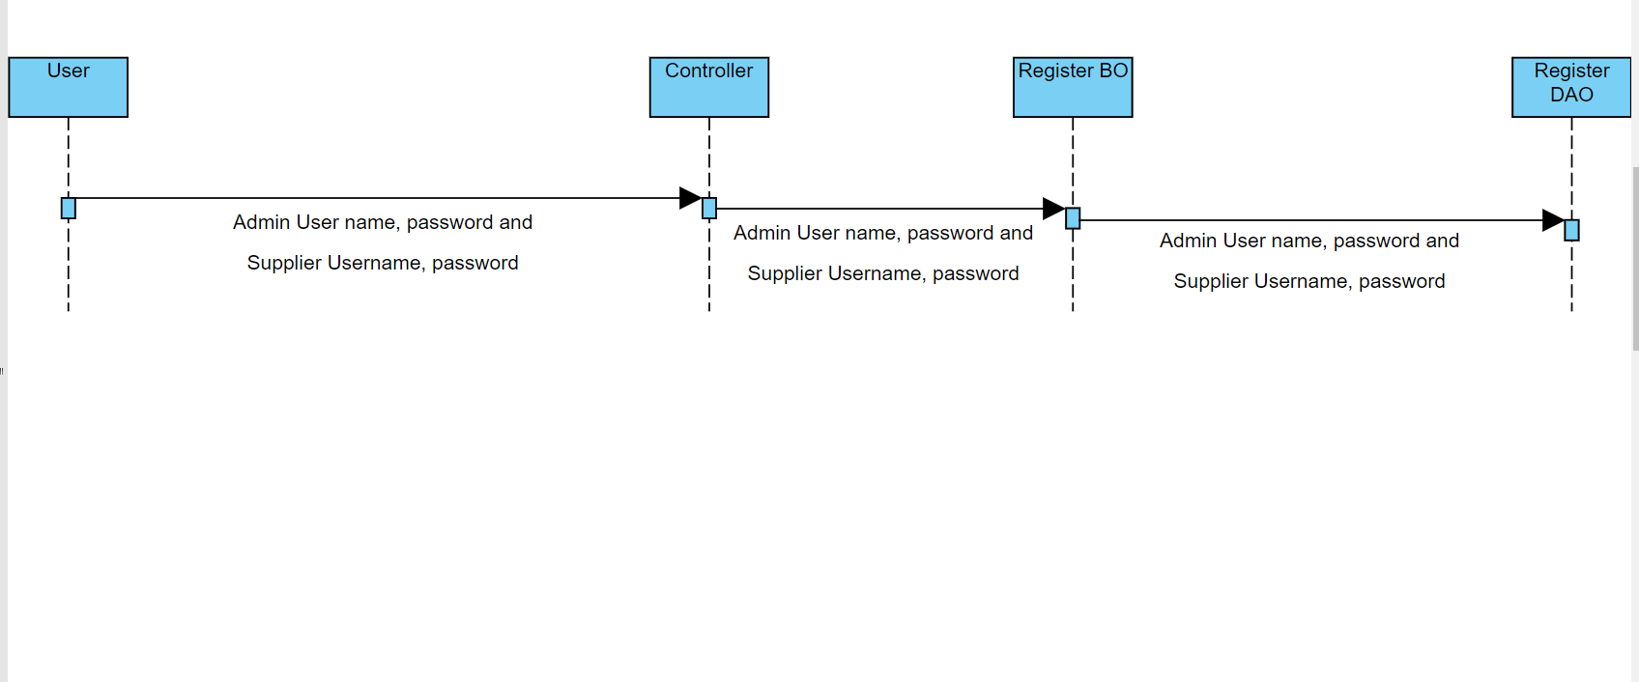

Business Rules

Business rules should be defined using the following attributes: -

- When the user (Admin/Supplier) clicks on the registration link, it should re-direct to registration form.
    - User needs to fill some of the basic attributes/fields as mentioned below in requirement: First Name, Last Name, Age, Gender, Contact Number, User Id, Password
- Clicking ‘Submit’ should validate the datatype constraints for each field
- Post-successful field level validation, save the information in the database
- Upon saving the information in the database, display the message ‘Your details are submitted successfully’.

UI Requirements
Here is a prototype on how the homepage should look like.

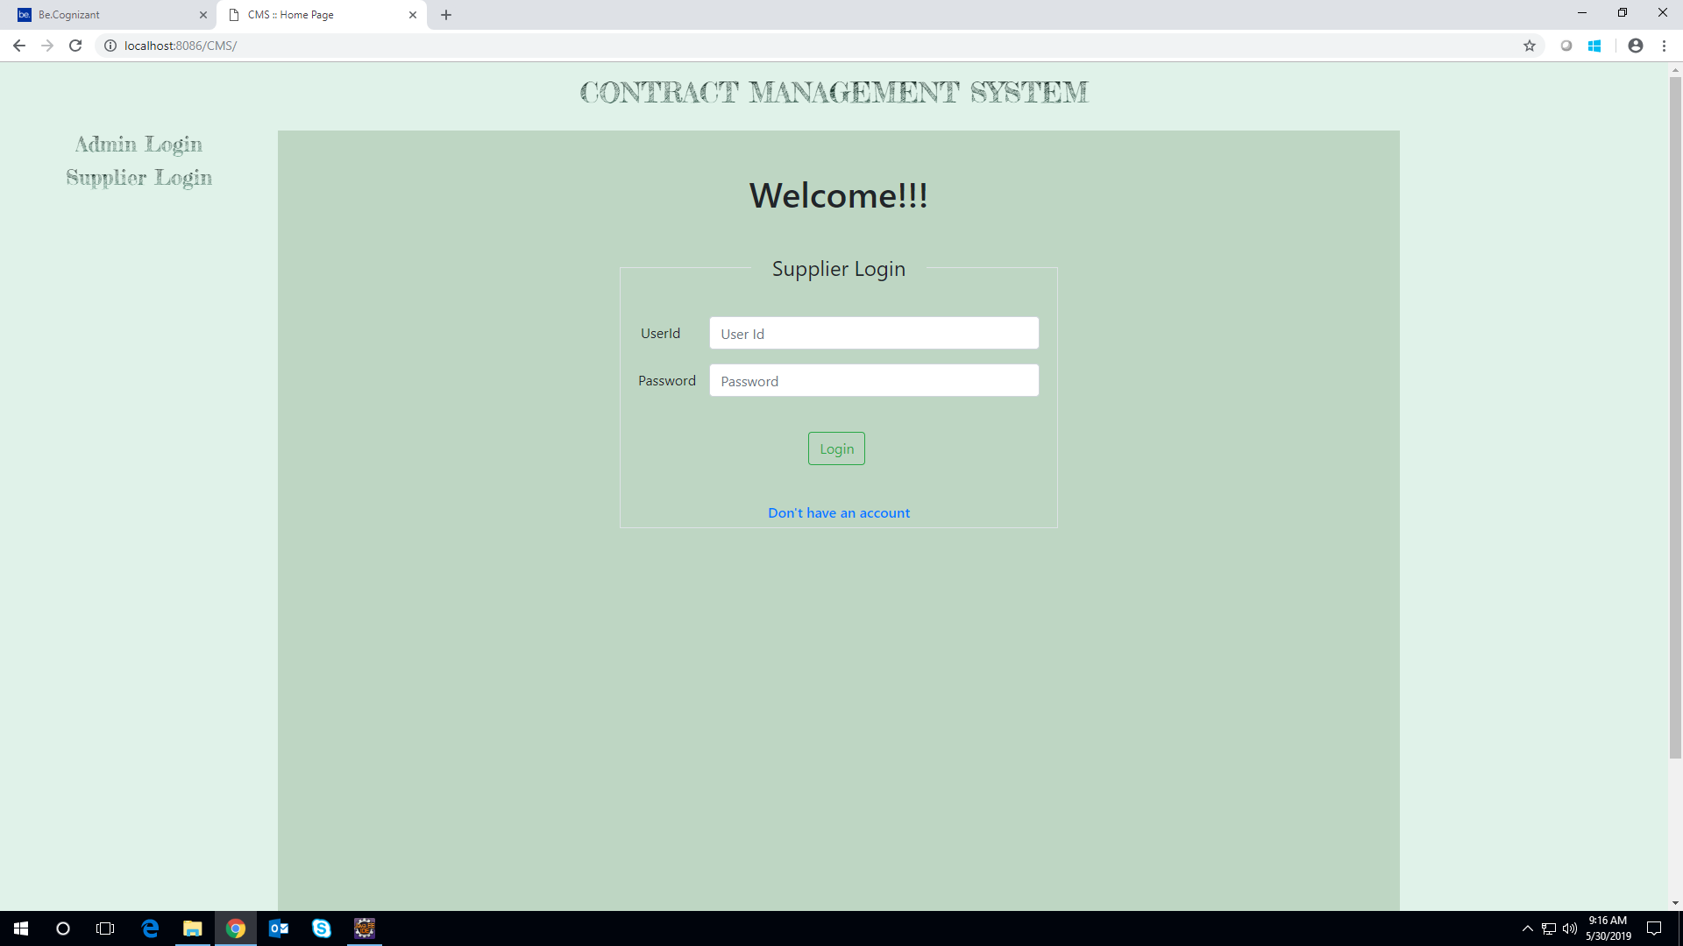

Here is a prototype on how the ‘User Registration’ page should look like.

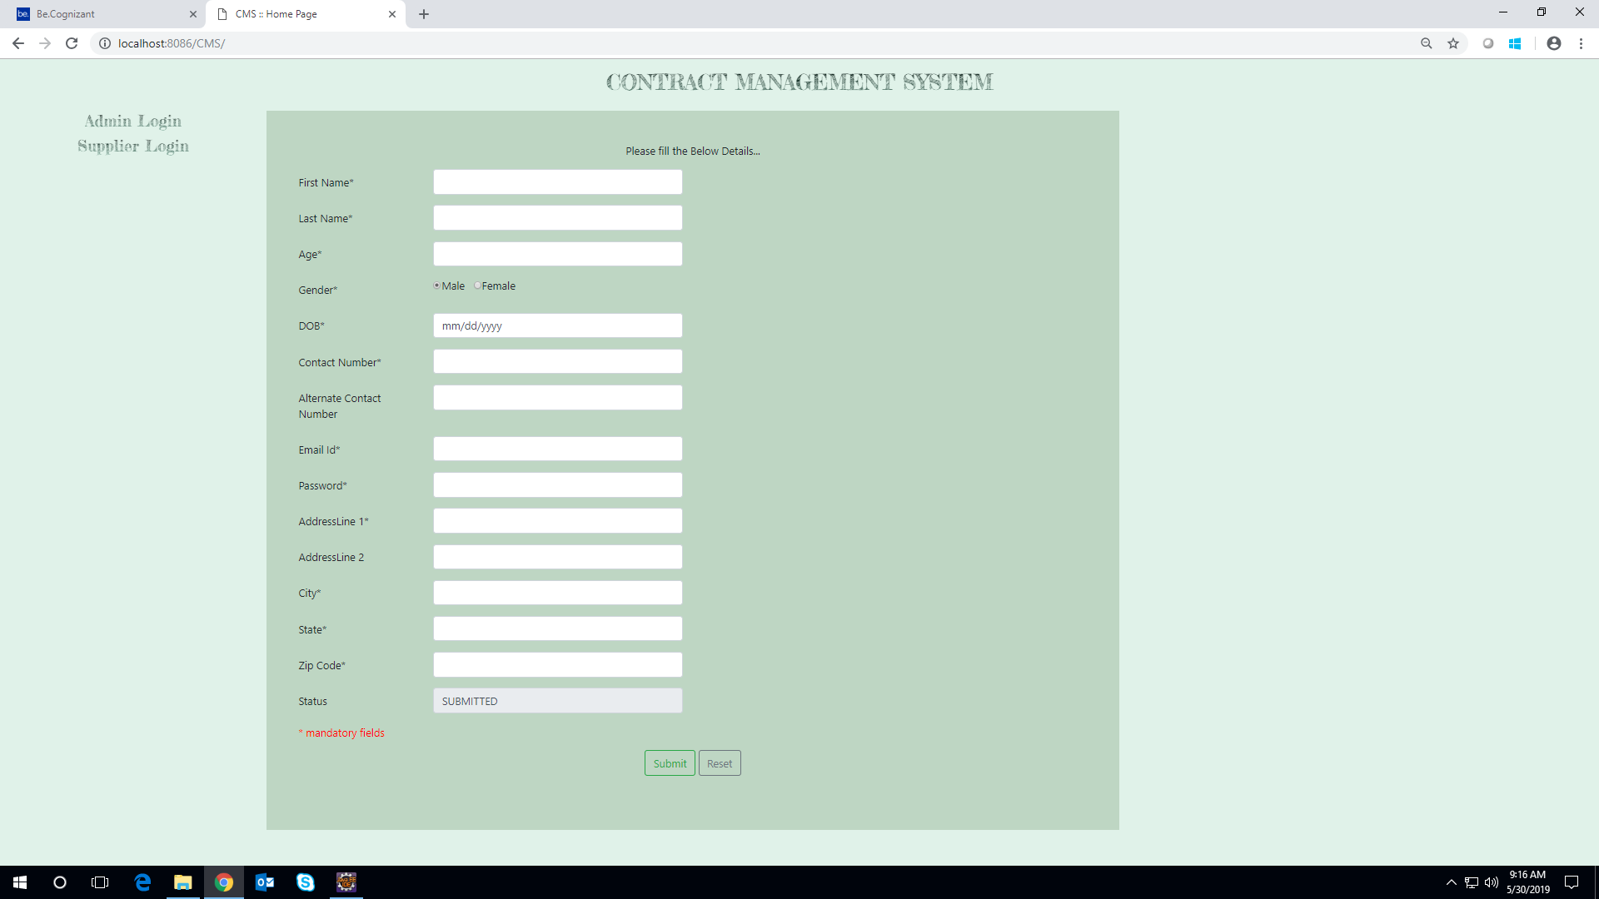

UI Field Validations
Please refer to the below requirements for field level validations:

- All fields are mandatory.
- Username should be less than 30 chars. Password should have minimum 8 chars, no space & can contain special characters (ex.!,@,#,%,*,& etc.)
- Password and Confirm Password fields should be the same
- The Email ID format must be checked. (For ex. test@testmail.com.)
- Phone Number must be of 10 digits’ length

Use case ‘Supplier Credential Authentication’

Use case attributes
Use Case Description:

This use case deals with the authentication of the Supplier credentials. The ‘Supplier’ here shall be the operator of the system and will be keying in the supplier information into the system.

Scope:

- Supplier credentials authentication

Actors:

Supplier– the operator

Trigger:

Click ‘Login’ link, after keying in ‘Supplier ID’ & ‘Password’ field.

Pre-Condition:

Supplier being able to access the homepage

Post Condition:

Supplier is in the supplier Registration page

Flow of Events:

User at homepage → Key in ‘Supplier ID’ & ‘Password’ field → Supplier credentials are validated → Supplier Registration page is displayed

Primary Scenario:
A registered user – is able click ‘Login’ link, after keying ‘Supplier ID’ & ‘Password’ field and get his credentials authenticated with the existing database entry.

Alternative Scenario:
A registered user – is able click ‘Login’ link, after keying in ‘Supplier ID’ & ‘Password’ field and unable to get his credentials authenticated. The user is presented with relevant error messages:

- Invalid Supplier ID – ‘The ‘Supplier ID’ provided does not exist in our records’
- Incorrect Password – ‘Password provided is incorrect. Please reach out to your system admin.’

Use Case Model
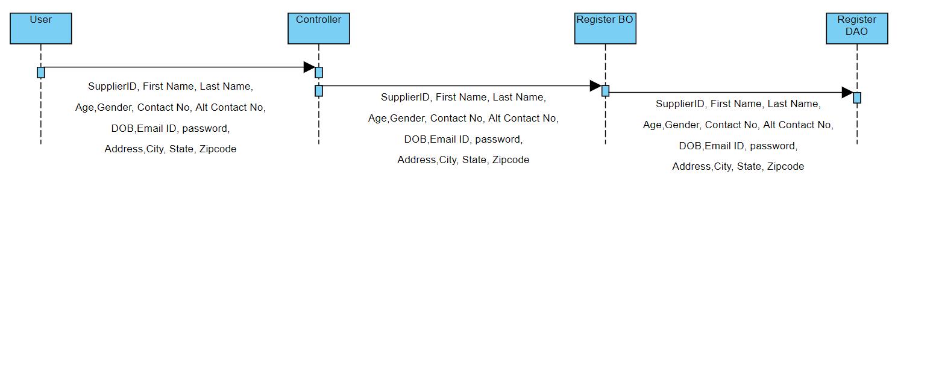

Business Rules
Business rules should be defined using the following attributes:-

- A registered user – is able click ‘Login’ link, after keying in ‘Supplier ID’ & ‘Password’ field and get his credentials authenticated with the existing database entry.

UI Requirements
Here is a prototype on how the Supplier registration should look like.

UI Field Validations
Please refer to the below requirements for field level validations:

- All fields are mandatory.
- Username should be less than 30 chars. Password should have minimum 8 chars, no space & can contain special characters (ex.!,@,#,%,*,& etc.)
- Password and Confirm Password fields should be the same
- The Email ID format must be checked. (For ex. test@testmail.com.)
- Phone Number must be of 10 digits’ length

Use case ‘Admin Credential Authentication’

Use case attributes
Use Case Description:

This use case deals with the authentication of the Admin credentials. The ‘Admin’ here shall be the operator of the system and will be keying in the Admin information into the system.

Scope:

- Admin credentials authentication

Actors:

Admin– the operator

Trigger:

Click ‘Login’ link, after keying in ‘Admin ID’ & ‘Password’ field.

Pre-Condition:

Admin being able to access the homepage

Post Condition:

Admin is in the Admin Registration page

Flow of Events:

User at homepage → Key in ‘Admin ID’ & ‘Password’ field → Admin credentials are validated → Admin Registration page is displayed

Primary Scenario:
A registered user – is able click ‘Login’ link, after keying ‘Admin ID’ & ‘Password’ field and get his credentials authenticated with the existing database entry.

Alternative Scenario:
A registered user – is able click ‘Login’ link, after keying in ‘Admin ID’ & ‘Password’ field and unable to get his credentials authenticated. The Admin is presented with relevant error messages:

- Invalid Admin ID – ‘The ‘Admin ID’ provided does not exist in our records’
- Incorrect Password – ‘Password provided is incorrect. Please reach out to your system admin.’

Use Case Model
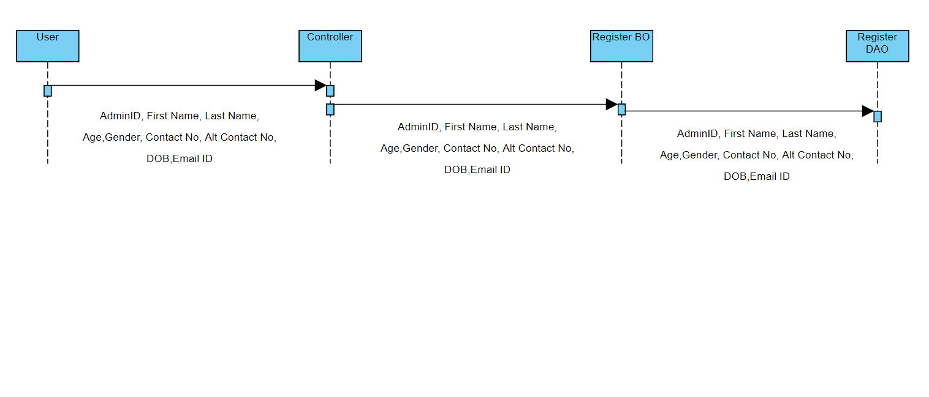

Business Rules
Business rules should be defined using the following attributes:-

- A registered user – is able click ‘Login’ link, after keying in ‘Admin ID’ & ‘Password’ field and get his credentials authenticated with the existing database entry.

UI Requirements
Here is a prototype on how the Admin registration should look like.

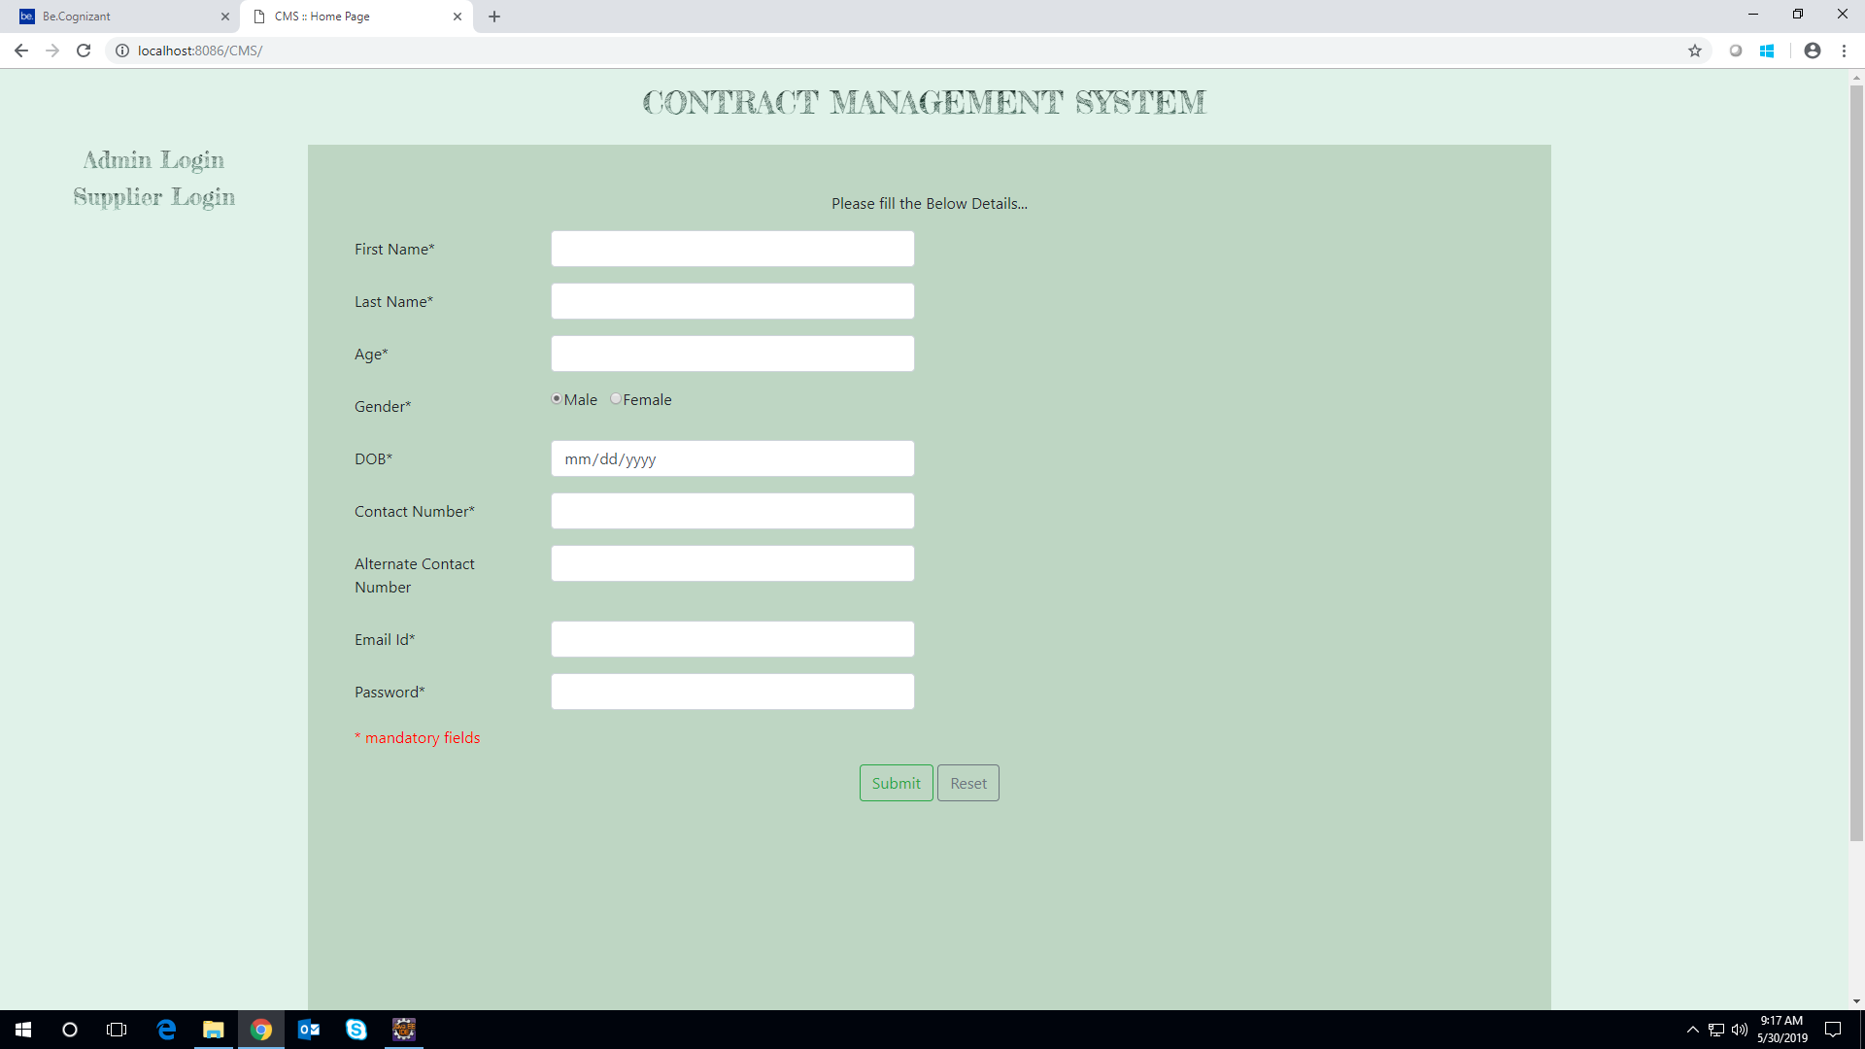

Database Design

Tables Structure

Supplier Registration:
Field Name | Field Type | Data Type | Mandatory
Supplier ID | Text(10) | Alphabetic | Yes
First Name | Text(50) | Alphabetic | Yes
Last Name | Text(50) | Alphabetic | Yes
Age | Numeric(2) | Numeric | Yes
Gender | Drop Down | NA
DoB | Text(10) | Alphanumeric | No
Contact Number | Text(10) | Numeric | Yes
Alt Contact Number | Text(10) | Numeric | No
Email ID | Text(50) | Alphanumeric | Yes
Password | Text(15) | Alphanumeric | Yes
Address Line 1 | Text(100) | Alphanumeric | Yes
Address Line 1 | Text(100) | Alphabetic | Yes
City | Text(50) | Alphabetic | Yes
State | Text(50) | Alphabetic | Yes
Zip Code | Text(10) | Numeric | Yes

Supplier login:
Field Name | Field Type | Data Type | Mandatory
Supplier ID | Text(10) | Alphabetic | Yes
Password | Text(15) | Alphanumeric | Yes

Admin Registration:
Field Name | Field Type | Data Type | Mandatory | Possible Values
Admin ID | Text(10) | Alphabetic | Yes | System Generated
First Name | Text(50) | Alphabetic | Yes
Last Name | Text(50) | Alphabetic | Yes
Age | Numeric(2) | Numeric | Yes
Gender | Drop Down | NA |  | Male, Female
DoB | Text(10) | Alphanumeric | Yes
Contact Number | Text(10) | Numeric | Yes
Alt Contact Number | Text(10) | Numeric | No
Email ID | Text(50) | Alphanumeric | Yes
Password | Text(15) | Alphanumeric | Yes | Password

Admin login:
Field Name | Field Type | Data Type | Mandatory
Admin ID | Text(10) | Alphabetic | Yes
Password | Text(15) | Alphanumeric | Yes

Contract:
Field Name | Field Type | Data Type | Mandatory | Possible Values | Field Name
Contract ID | Auto- generated(8) | Numeric | Yes | Non- editable system generated | Contract ID
Contract Description | Text(200) | Alphabetic | Yes |  | Contract Description
Contract Submission Date | Text(10) | Alphanumeric | Yes |  | Contract Submission Date
Contract Processing Date | Text(10) | Alphanumeric | Yes |  | Contract Processing Date
Contract status | Text (10) Drop down | Alphabetic | Yes | Submitted Approved Denied | Contract status

Terms & Conditions:
Field Name | Field Type | Data Type | Mandatory | Possible Values
Contract ID | Auto- generated(8) | Numeric | Yes
Term1 | Text(100) | Alphabetic | Yes
Term2 | Text(100) | Alphabetic | No
Term3 | Text(100) | Alphabetic | No
Term4 | Text(100) | Alphabetic | No
Term5 | Text(100) | Alphabetic | No
Condition1 | Text(100) | Alphabetic | Yes
Condition2 | Text(100) | Alphabetic | No
Condition3 | Text(100) | Alphabetic | No
Condition4 | Text(100) | Alphabetic | No
Condition5 | Text(100) | Alphabetic | No

Amenities:
Field Name | Field Type | Data Type | Mandatory | Possible Values
Contract ID | Auto- generated(8) | Numeric | Yes
Amenities1 | Text(100) | Alphabetic | Yes
Amenities2 | Text(100) | Alphabetic | No
Amenities3 | Text(100) | Alphabetic | No
Amenities4 | Text(100) | Alphabetic | No
Amenities5 | Text(100) | Alphabetic | No
Other Info | Text(100) | Alphabetic | No

Change Log
Version Number | Changes Made
V1.0 | Initial baseline created on 06/06/2019 by Vineka Vellimalai, Deepika Gnanamoorthy, Vignesh U
V 2.0 | Section No. | Changed By | Effective Date | Changes Effected
V 2.0 |  | Vineka Vellimalai, Deepika Gnanamoorthy, Vignesh U | 6/6/2019 – 6/10/2019 | Supplier able to check the contract status by giving the contract id
V 2.0 |  | Vineka Vellimalai, Deepika Gnanamoorthy, Vignesh U | 6/10/2019 – 6/18/2019 | Automatic Rejection of Supplier when the supplier is not approved by the admin for 5 days

